**Homework 2**

Github Repo: <https://github.com/Rongxuan-Zhou/EECE5642-Data-Visualization/tree/main/HW2>

1. **Visualization Design**
2. **Bad Design:**

<https://junkcharts.typepad.com/junk_charts/2025/01/ranks-labels-metrics-data-and-alignment.html>, contained graphs are attached below:

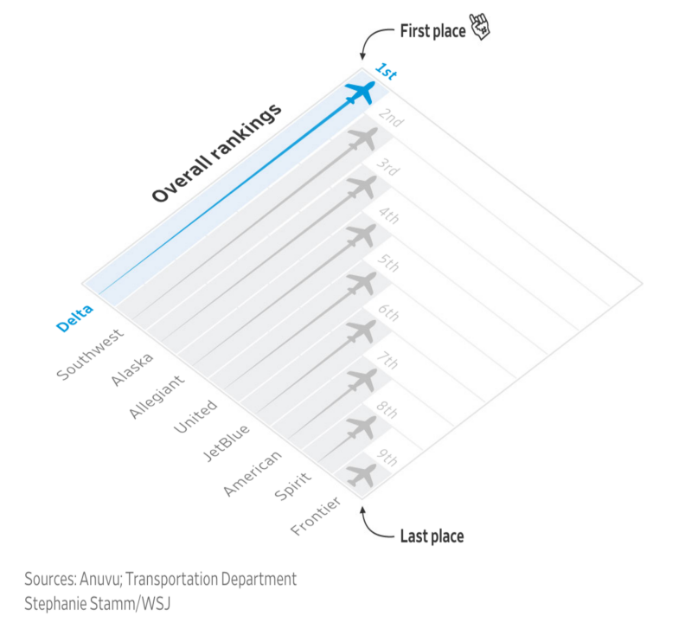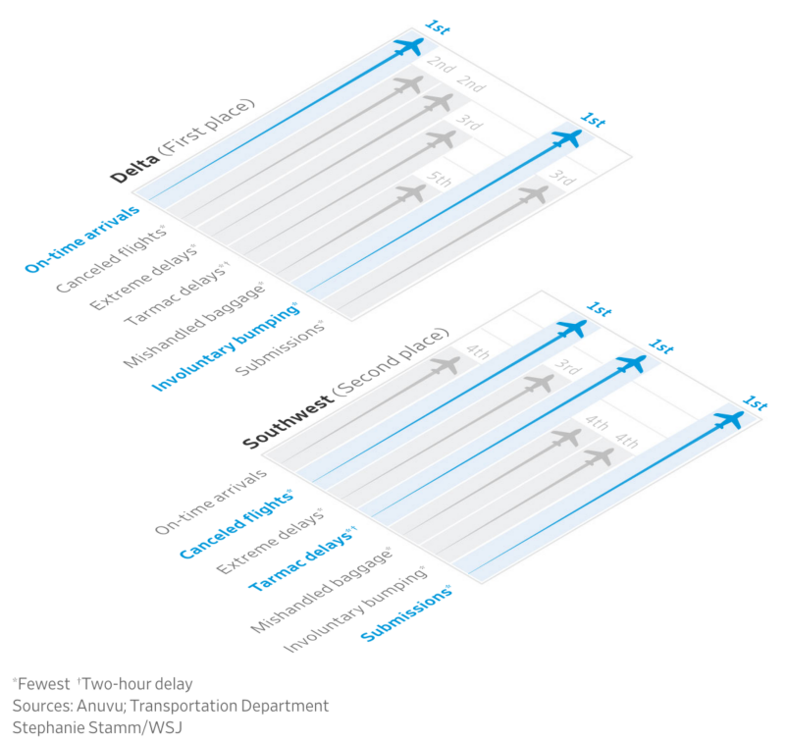

junk chart1 junk chart2

**Data-ink Ratio Issues:**

The 45-degree slanted design creates excessive non-essential white space;

The airplane icons are decorative and convey no actual information;

Redundant labels and legends occupy too much space.

**Lie Factor Analysis:**

The reverse ranking representation can be misleading;

Asterisk annotations are needed to explain meanings, increasing cognitive load;

Using longer bars to represent "best" contradicts intuitive understanding.

**Clarity Issues:**

Text labels at 45-degree angles are difficult to read;

Multi-level information display complicates simple data;

Requires head tilting for proper information reading.

1. **New Design:**

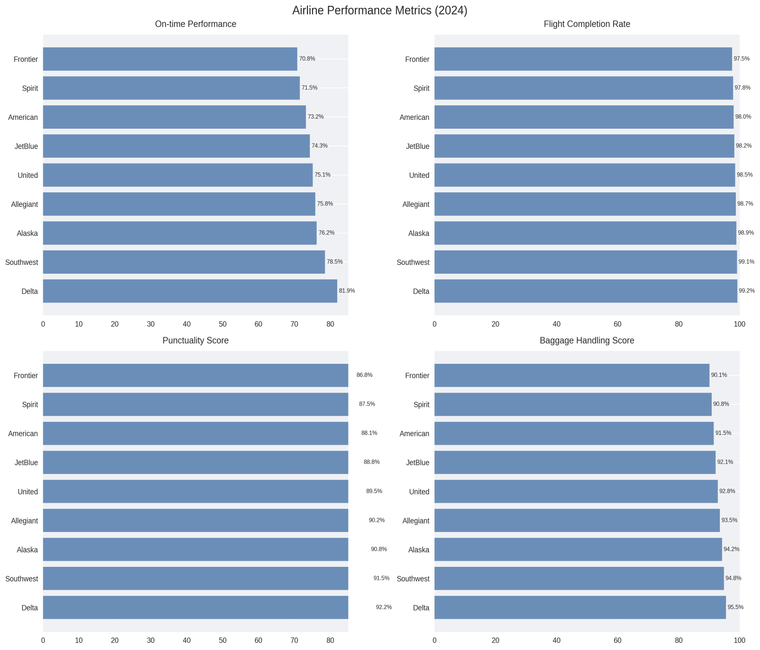

**Readability Improvements:**

Use horizontal bar charts to avoid tilted text;

Display performance values directly instead of rankings;

Use clear metric names and avoid negative phrasing.

**Information Display Optimization:**

Group related metrics together;

Use gridlines to assist value comparison;

Add percentage labels for intuitive performance display.

**Visual Enhancement:**

Remove decorative elements (such as airplane icons);

Use subtle gridlines;

Adopt a clear color scheme.

**Functional Improvements:**

Display actual performance data directly;

Simplify information hierarchy;

Provide intuitive data comparison.

1. **Color**
2. **Coding Resource:**

The colorsys module from Python's standard library;  
Matplotlib library for creating color swatches;  
NumPy library for numerical computations;  
Colormath library for more precise color space conversions;

EasyRGB's color conversion formulas (<http://www.easyrgb.com/en/math.php>);  
Wikipedia's color space conversion entries;  
Bruce Lindbloom's color transformation equations ([http://www.brucelindbloom.com](http://www.brucelindbloom.com/)).

1. **Results:**

R = 137/255 = 0.5373

G = 56/255 = 0.2196

B = 146/255 = 0.5725

XYZ: (0.4034, 0.3126, 0.5808)

xyY: (0.3111, 0.2411, 0.3126)

CMYK: (0.0616, 0.6164, 0.0000, 0.4275)

HSV: (0.8167, 0.6164, 0.5725)

HSL: (0.8167, 0.4455, 0.3961)



This color is a purple hue, leaning towards magenta in the RGB color space, with medium brightness and moderate saturation.

1. **Table & Graph**

In this section, partial dataset ranging from year 2016 to 2020 is picked, with generated table and graph attached below:

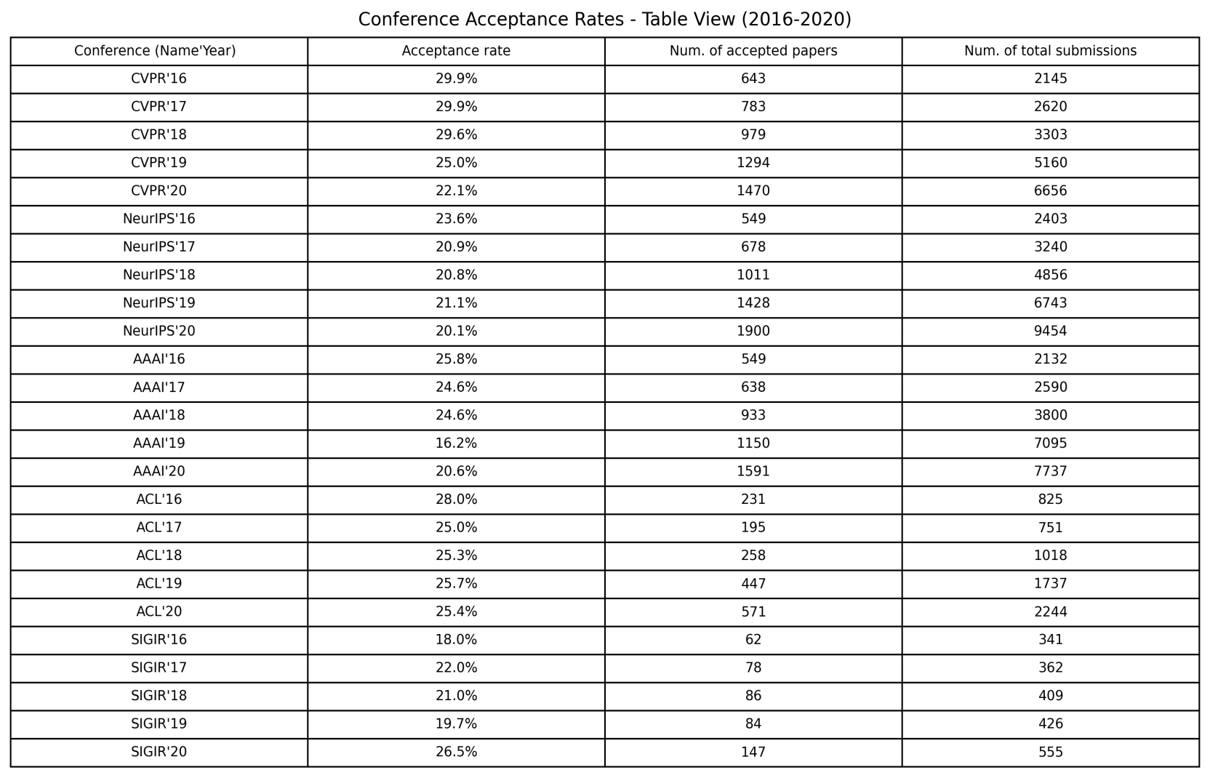

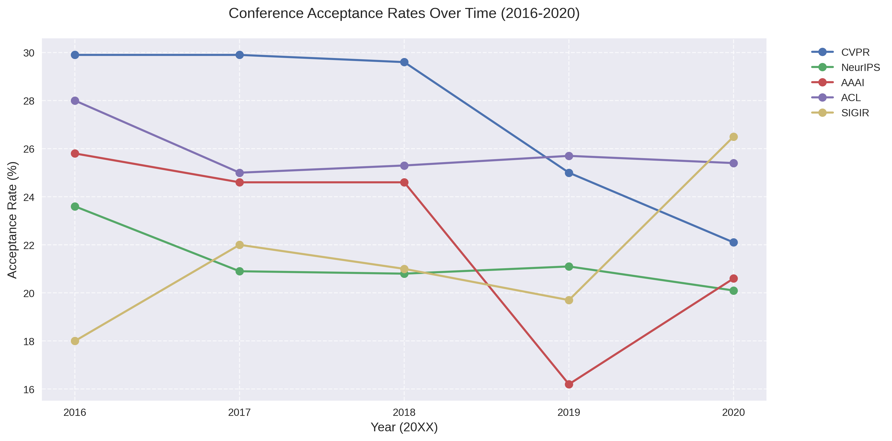

**Visualization Comparison Analysis:**

1. **Table**

Pros: Precise presentation of exact values;

Easy to look up specific numbers;

Good for comparing individual values;

Shows all three metrics (acceptance rate, accepted papers, total submissions).

Cons: Difficult to see trends over time;

Takes more space to display;

Requires more time to process information.

1. **Graph**

Pros: Clear visualization of trends over time;

Easy to compare patterns between conferences;

Intuitive understanding of acceptance rate changes;

Compact representation of temporal patterns.

Cons: Only shows acceptance rate (not paper counts);

Can become cluttered with too many conferences;

Less precise for exact values.

1. **Visual Perception and Cognition**

Analyze the two pics from the perspective of visual perception and cognitive psychology.

1. **Visual Perception Level**

Physical Similarity: Both images use the same bright yellow (#FFFF00) background;

Three characters arranged with equal spacing, balanced visual weight;

Using the same geometric sans-serif font with consistent stroke width.

Gestalt Principles:

Principle of Proximity: Three characters are perceived as a unit due to close spacing

Principle of Continuity: Character arrangement creates a sense of sequence

Principle of Closure: Yellow background encloses the character combination into a visual unit

1. **Cognitive Processing Level**

Context Effects:

Left image: "B" placed between A and C, alphabet sequence knowledge activated with the alphabet mental model (A→B→C)

Right image: "B" placed between 12 and 14, mathematical pattern knowledge activated (right image: arithmetic sequence, difference of 1) with the numerical sequence model (12→13→14)

Cognitive Processing:

Automatic processing: Quick recognition of basic letter and number shapes

Controlled processing: Inferring different meanings of "B" based on context

Left image "B" → Letter "B"

Right image "B" → Substitute symbol for number "13"

1. **Cognitive Conflict and Resolution**

Cognitive Conflict:

Symbol ambiguity: Same "B" symbol creates cognitive competition in different contexts

Category switching: Need to switch between letter and number systems

Resolution Mechanisms:

Context dependency: Using surrounding information to resolve ambiguity

Experience application: Applying existing sequence knowledge (alphabet order/numerical progression)

Pattern completion: Automatically filling in missing sequence items